**Synopsis**

**Project Details**

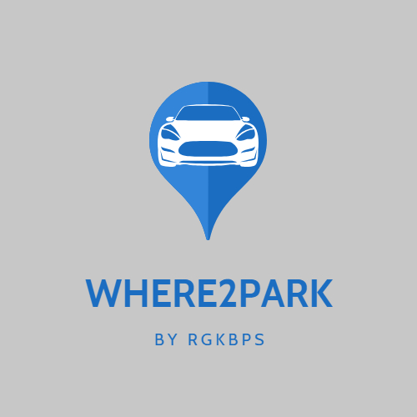

**Ministry/Department Category:** Small

**Problem Statement:** How to find your vehicle in night in a big parking lot. When there is a big ground having thousands of vehicles and you have to find your bike, scooter or cycle?

**Team ID:** TG000775

**College Name:** Raksha Shakti University

**Team Leader Name:** Mr. Akshat Soni

**College Code:** U-0595

**Abstract**

**:** We will build a web based system for users to check for the vacant block for their vehicle to be parked-in, the user will open the system and will look for the vacant blocks from the layout provided on the website by just entering their vehicle registration no. and their name, the users will be informed regarding the parking block information through the sms/mail/on-screen notification, so that they can easily find their vehicle just looking into the message/notification. The parking block will be vacant by the user himself or the parking lot admin, they can simply vacant the block by the option provided in the system.

**Existing technology to address related to your problem:**

: According to the existing system for parking, the parking slips are given to users to allot the space for parking their vehicle, and user has to remember where their vehicle was parked and using this method it becomes difficult to find vehicle specially in the night conditions, also there is no systematic parking everywhere, users sometimes have to find a place by themselves to park the vehicle or they have to adjust others vehicles to park their own vehicle. And this problem becomes more complex when the situation is of night hours.

**What would be your approach to solve the problem:**

: In our approach, The parking lot will be divided into two blocks for Two-Wheeler, Four-Wheeler. There will be separate slots for each vehicle in both the blocks. The user will require to login to the website. The user will be provided the layout of the parking lot on the website from which the parking slots will be alloted to the user, after allotting the parking slots, the user will receive a text message containing the information regarding the alloted slot, in this way the problem of locating the in the parking will be solved.

**Flow Diagram of Solution:**

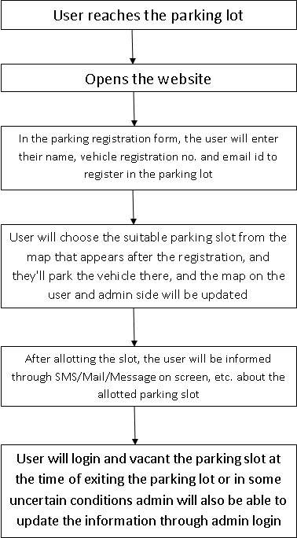

**Tools and Technologies to be used:**

**IDE:**

Notepad++:- It supports tabbed editing, which allows working with multiple open files in a single window.

**Server :**

Apache:- Apache supports a variety of featuresto extend the core functionality. A server is required for running PHP script Apache will be used in our project.

**Languages:**

PHP:- Hypertext Preprocessor is a server-side scripting language designed for Web development.

**Scripts:**

Java Script:- JavaScript is a scripting and GUI habdling language. Java Script will be used for scripting GUI based controls.

CSS:- Cascading Style Sheets is a style sheet language used for describing the presentation of a document written in a markup language like HTML. CSS will be used for describing the presentation of Web pages, including colors, layout and fonts.

**Database:**

MySQL:- MySQL is a Relational Database Management System (RDBMS) that uses Structured Query Language (SQL). As user has to enter some data and it has to be stored as Data storage is required MySQL will used.

**Challenges/Risk in implementing your Final prototype:**

1. Usually the current parking spaces available are the simple open space and we need to update that space by dividing the whole pace among various slots and do the naming of them as well. It requires time and efforts and by the time these physical installation takes place the parking space will be unnecessarily busy.

2. Parking space is filled according to slots available, so it is to be ensured that there is an efficient way of parking so that each vehicle get proper position and from there they can easily get out.

3. At some areas mobile network is not available so it causes problem for the user to logon to the website and select the parking space.

**Possible outcome of your work:**

: As per the definition of the problem we tried to come up with the optimum solution according to us. The user will be able to easily find the vehicle in the parking lot as they will be having information about the exact location of the vehicle, in a form of block number (selected by themselves ) in which they

have parked the vehicle, so it will become so easier rather than wasting time in randomly and cluelessly finding the vehicle in the huge parking lot. As well as it is affordable and reliable project to set up with possibly minimum expense that is eventually a big plus point for the developer also that they will not have to invest somewhat good amount.

**Work done till date:**

Front End Planning: Front-End Planning is under progress, we have designed some templates for the webpages like template for the parking lot map page, the template for the vehicle registration form, etc. which are also there in attachments.

Front End Implementation: This task is under planning right now, we will start implementing the GUI soon as the planning completes, the GUI will be implemened with the help of HTML, CSS, & JavaScript (jQuery).

Back End Planning: Back Planning is also under progress, we have designed the templates and we are planning for the backend implementation through PHP and JavaScript.

Database Planning & Management: We have also planned the datas to be stored and we have also almost completed the database planning.

Overall progress of the project is almost 30%.

**Image/Screenshot/Video link of your solution:**

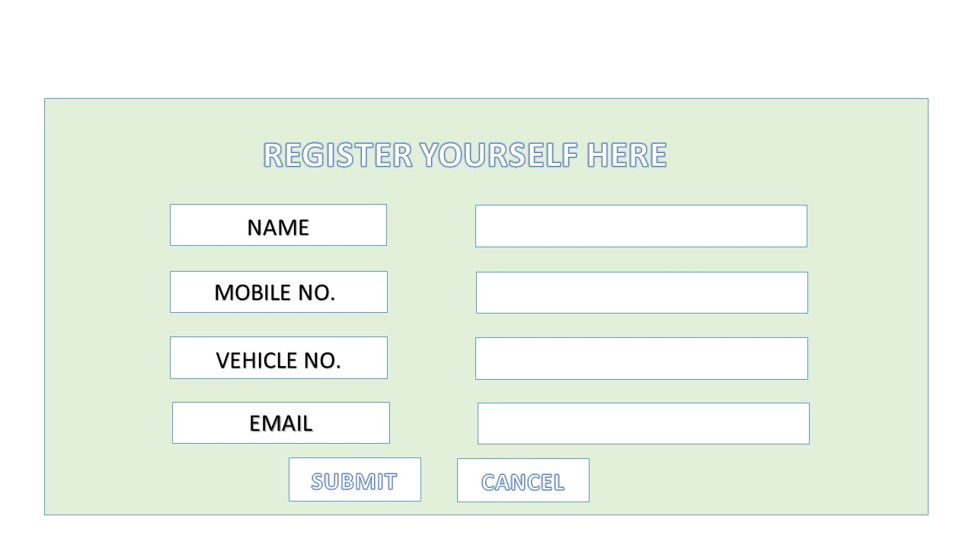

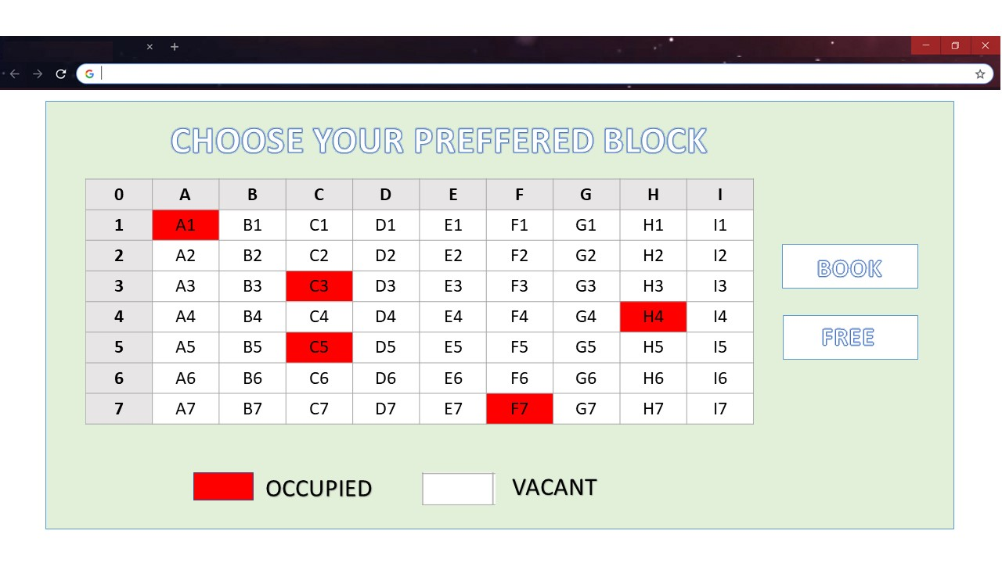

(This is planned design of the solution not the actual design)